www.tasconline.org

Why Should Your Students Take A Leadership Class?
Why Should Your Students Attend Leadership
Workshops And Conferences?
Why Should You Support Student Council?
Do Leadership Training and Development make a difference in the public sector? A Panel Student
Authors: Brett Seidle, Sergio Fernandez, James Perry Published: February 29, 2016
“This research attempts to answer the question of whether leadership training and development programs in the public sector improve leader and organizational performance. The findings indicate that a combination of coaching, classroom instruction, feedback, and experiential training has a significant impact on leader performance.”
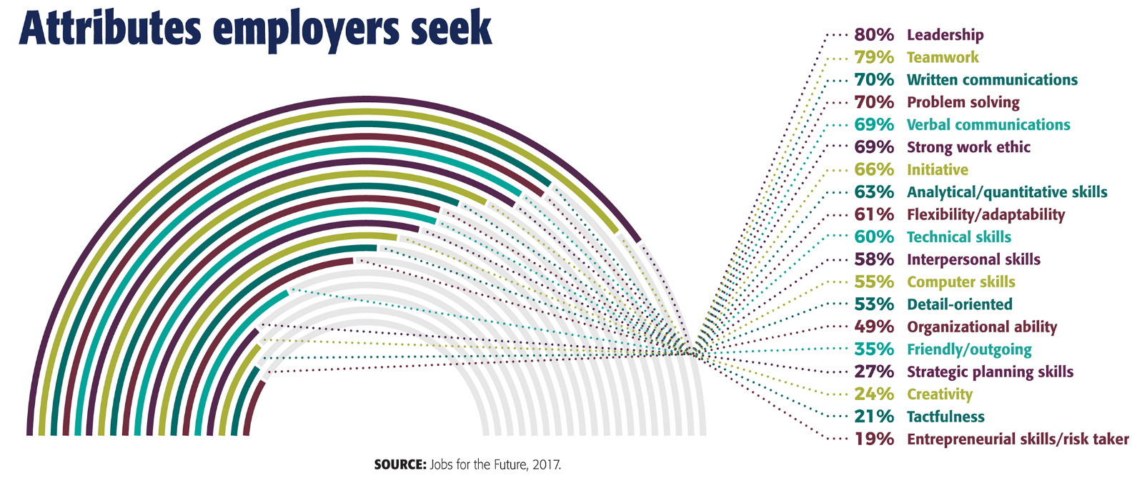

WHAT INFLUENCES AN EMPLOYER TO HIRE ONE CANDIDATE OVER ANOTHER?
Major……………………………………………………………………………………………………………………………………………..4.0
Has held leadership position…………………………………………………………………………………………………………..3.9
Involvement in extracurricular activities (student government, clubs, sports, etc.)…………………………3.6
High GPA (3.0 or above) ......................................................................................................................3.5
The school attended………………………………………………………………………………………………………………………..2.9
Has done volunteer work…………………………………………………………………….………………………………………….2.8

